Q. How to upgrade Jenkins server which is running inside the docker container?

Ans:

* Login to container as root user

Exa: **docker exec –u 0 –it Jenkins /bin/bash**

Note: here **0**(zero) used for root and **Jenkins** as container name.

* Create a directory for keeping the old Jenkins.war backup.

Exa: **mkdir Jenkins-war**

* Copy the current Jenkins.war(/usr/share/Jenkins/Jenkins.war) file to Jenkins-war

Exa: **cp /usr/share/Jenkins/jenkins.war Jenkins-war**

* Then got to jenkins dashboard and Right click on the download link and “copy link address”

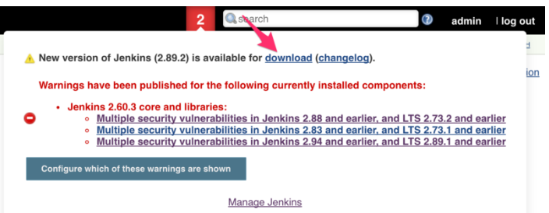

* Then go inside the container and download the latest Jenkins

Exa: **wget <URL>**

* Then move the latest downloaded Jenkins.war to /usr/share/Jenkins/Jenkins.war

Exa: **mv Jenkins.war /usr/share/Jenkins/**

Press **y** if asking for overwrite confermation

* Change owner of Jenkins.war

Exa: **chown Jenkins:Jenkins /usr/share/Jenkins/Jenkins.war**

* Exit the container and restart the container.

Exa: **exit**

Exa: **docker restart Jenkins**

* We needs to upgrade plugins also. So

login to Jenkins dashboard – manage plugins and select the plugins and click download now and update after restart.

